Docker Containerized AddressBook Application

Step1 : First clone addressbook application using git clone command
git clone https://github.com/Abhijeet41/addressbook-demo.git
Step2: navigate to this address-book application create docker file
o/p
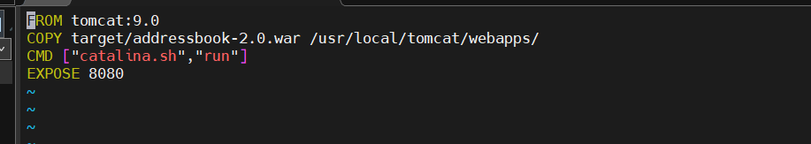
Step3: first install maven to run this addressbook application so it will generate .war file so we can copy
that in ../tomcan/webapps path.
sudo apt install maven
o/p
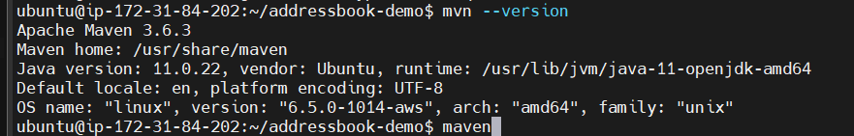
Step4: now install below command to create .war file
mvn clean package
o/p : here we get our .war file
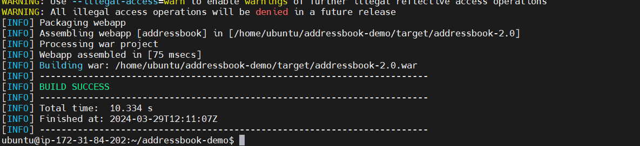
Step5: Now lets create Docker Build
docker build -t addressbook .

Step6: run Addressbook image
docker run -td -p 80:8080 addressbook:latest

Finally you will be able to see on browser addressbook app is hosted but before check on browser make sure port 80 is enabled in security group
Note .war file name should be put in browser along with ip and port .war = addressbook-2.0
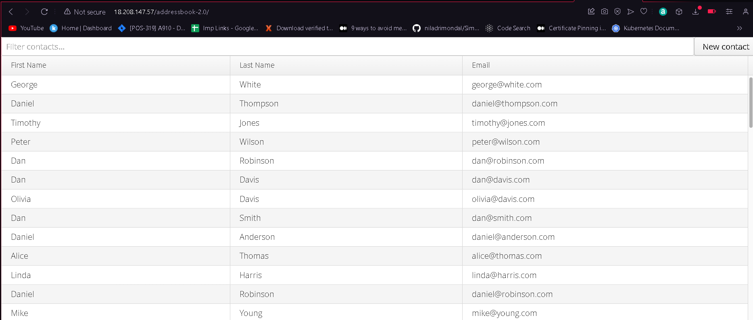

-------------------Another MVN based application host using docker---------------------------

Step 1: Make sure docker is already installed and clone project repository from github
git clone https://github.com/MithunTechnologiesDevOps/maven-web-application.git

Step2: Get into that project repositoly and creat Dockerfile using below command
vi Dockerfile
FROM tomcat:8.0.21-jre8
COPY target/maven-web-application.war /usr/local/tomcat/webapps/maven-web-application.war

Step3: first install maven to run this addressbook application so it will generate .war file so we can copy
that in ../tomcan/webapps path.
sudo apt install maven
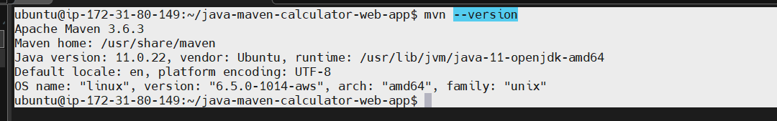
Step4: now install below command to create .war file
mvn clean package
Step5: Now lets create Docker Build
docker build -t mithun _technology .

Step6: run mithun _technology image
docker run -td -p 81:8080 mithun _technology :latest

Finally you will be able to see on browser mithun _technology app is hosted but before check on browser make sure port 81 is enabled in security group

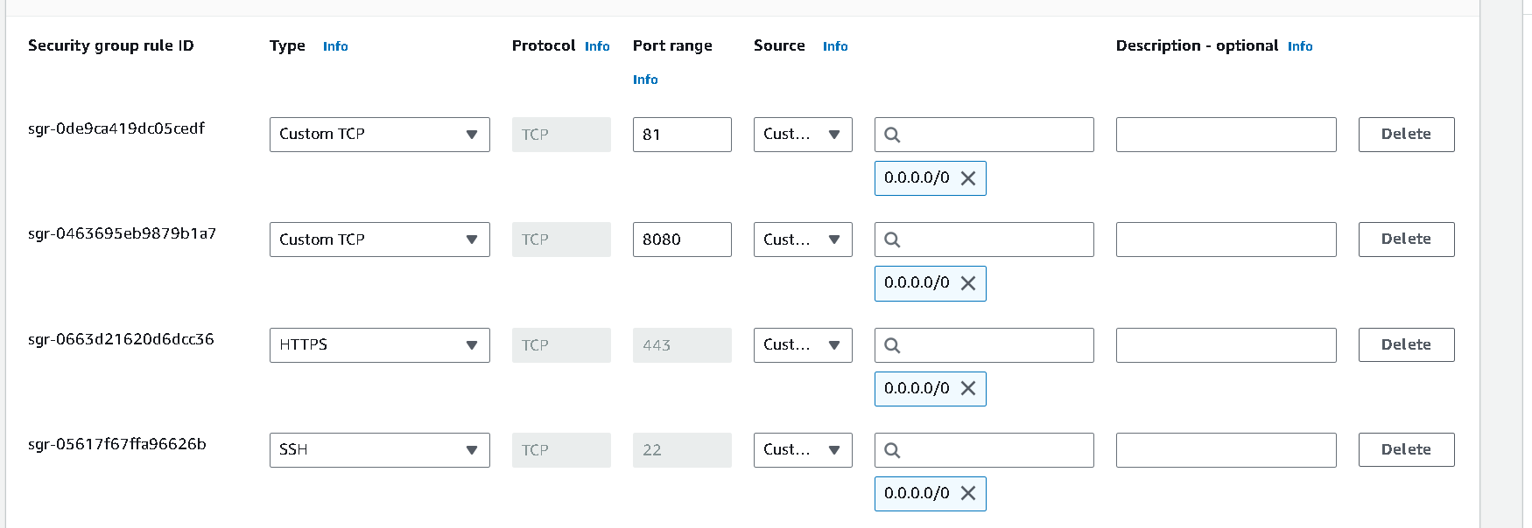
Now finally see the output on web browser
Note .war file name should be put in browser along with ip and port .war = maven-web-application/

